Mapping information in a diagram means the relationships between ideas can be shown and they hopefully become easier to understand and remember. Mapping promotes deeper learning because learners actively work with the information and the diagrams makes information visual (pictures) as well as verbal (words).
Mind Mapping
The aim of mind mapping (or “idea” mapping) is to make connections and associations between ideas in a creative and spontaneous way. The aim is to encourage creative thinking. Formal mind mapping techniques involves different line thicknesses, colours, pictures and diagrams to help the learner recall the information more easily. The first example picture and the steps below are adapted from http://www.tonybuzan.com/about/mind-mapping/. Tony Buzan has also written books about mind mapping.
- Start in the CENTRE of a blank page turned sideways (landscape) so you can spread out in all directions more freely and naturally.
- Use an IMAGE or PICTURE for your central idea to communicate your main idea efficiently with less words, to encourage your imagination, and keep you focused.
- Use COLOURS throughout to make your mind map more vibrant and interesting to look at.
- CONNECT your MAIN BRANCHES to the central image and connect your second- and third-level branches to the first and second levels, to show the associations.
- Make your branches CURVED rather than straight-lined to keep the mind map interesting
- Use ONE KEY WORD PER LINE; key words give your Mind Map more power and flexibility.
- Use IMAGES throughout because each image is worth a thousand words.
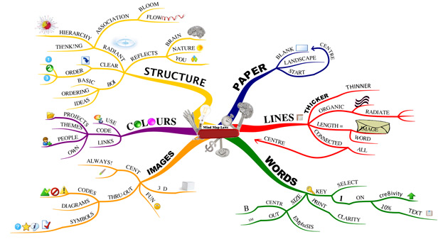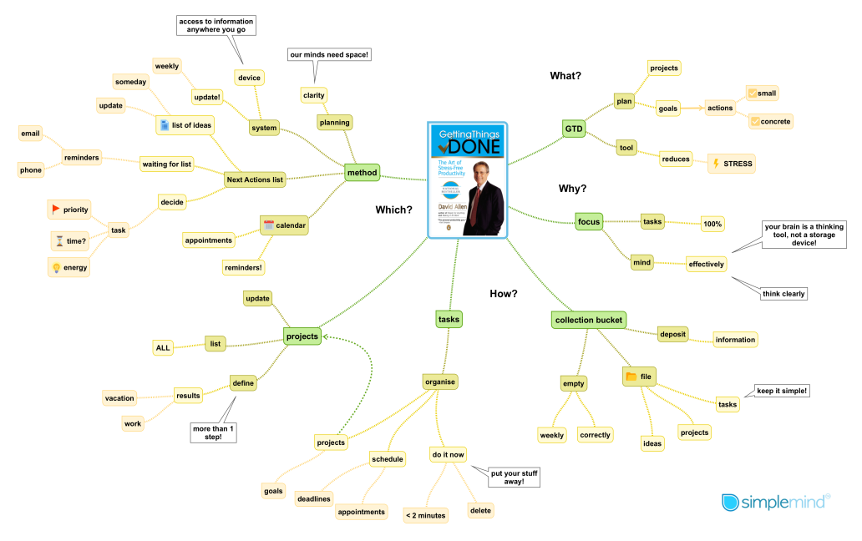
There are lots of mind mapping websites and apps such as SimpleMind (https://simplemind.eu/) which has a free version and can be used on computers, phones or tablets like the iPad.
Concept Mapping
Concept mapping is more structured and has fewer pictures, and can be more complicated. It is often confused with mind mapping. The aim of concept mapping is to show specific forms of relationships between ideas by connecting the main ideas with lines that are labelled. Concepts maps generally have a hierarchy or order. They often start with a focus question in the form of a word or phrase, then the concept map is created to try and explore and answer the focus question. The linked ideas use connective terms (prepositional phrases) such as “leads to”, “results from”, “is part of”, etc. The steps and the example pictures below are adapted from an article about concept mapping (http://cmap.ihmc.us/docs/constructingaconceptmap.php) that is on the Cmap website. Cmap has a downloadable tool that can be used on iPads for free (https://cmap.ihmc.us/cmaptools-for-ipad/).
- Decide on the focus question; a question that clearly shows asks the specific problem or focus of the concept map.
- Think of all the key ideas or concepts that could apply to the focus question and make a note of these, like the first example below about birds.
- Concepts maps are hierarchical, the ideas are in an order. Rank the ideas and sort them so the more general ideas are at the top (or at one side) and the more specific ideas are towards to bottom (or other side)
- Create the initial concepts maps and start to show how the ideas are linked by adding the ‘cross-links’ or lines with the connecting phrases. The cross-links should be specific and tend to include a verb or action word.
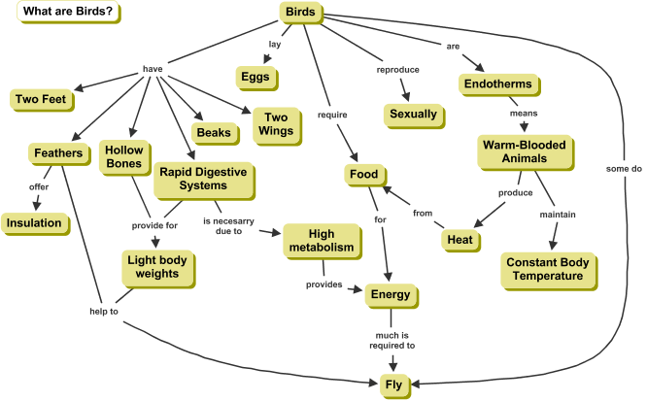
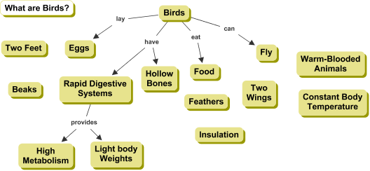
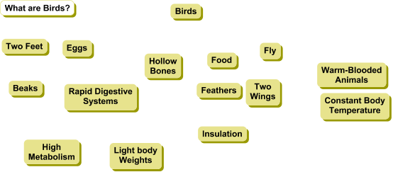
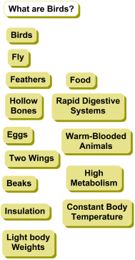
- Revise the concept map. Good concept maps are revised and improved to make it as clear as possible. It is important to realise and show that all the concepts are related in some way. The concepts may need to be moved around or changed slightly. Concepts maps are rarely finished because you can continue to refine them.
2
5
4
1
3

