App name | Cost & Privacy Info | Age range | Description | Compatible phones
Mindshift   | Free | Teens (13+) | Allows you to pick a situation you would like help with from a list (e.g. tackling social fears), then read the facts about social anxiety, before rating the severity and selecting all the physical symptoms that apply.  There are a range of situations available including dealing with intense emotions, sleep, managing worry, test anxiety, social fears, performance anxiety, dealing with conflict, panic, and perfectionism. The app then supports you to create a plan, breaking it down into steps to tackle avoidance.  The app enables you to collect a folder of favourite coping thoughts and chill out tools (including calm breathing audio & PMR). | IOS & Android    MindShift is the work of a joint collaboration between AnxietyBC and BC Mental Health & Addiction Services.
Smiling Mind  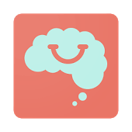 | Free | Offers different programs for different ages:  - 7-9  - 10-12  - 13-15  - 16-18  adults | Has sample meditation that you can do without creating account or logging in – involves 5 minute body scan with audio instructions.  Once you create account – gives you access to multiple relaxation programs, including ‘digital detox’ one. There is also a ‘mindfulness in the classroom’ program and different programs for different age groups. | IOS & Android
Catch it   | Free  Requires you to set 4 digit pin.  Asks for permission to anonymously share diary entries with Liverpool University – you can refuse. | Secondary school age. | Helps users better understand their mood through the use of an ongoing diary.  Record mood, including rating, when it was experienced and where you were and what you were doing. Asks you to identify your thoughts, and asks you to take an alternative perspective – what would you say to a friend? Then asks you to re-rate your mood. You can also share your diary via email. | IOS & Android  Joint project between Manchester and Liverpool University.
App name | Cost & Privacy Info | Age range | Description | Compatible phones
Headspace  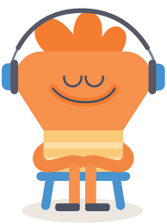 | Free to download app & complete Basics module – can delete app and re-download to regain access to basic module.  Monthly subscription cost (£9.99) after this. | Basics Module – secondary school age  Kids modules (for £9.99 monthly subscription):  - <5  - 6-8  - 9-12 | Free Basics module has 10 (10-minute) exercises teaching the essentials of mindfulness. Completing one unlocks the next in the series.  Monthly subscription provides access to several modules including specific Kids Headspace with modules on sleep, kindness and balance. | IOS & Android
Flowy  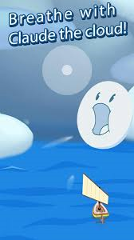 | Free | All ages – younger children will probably need to be shown how the breathing relates to the game though. | The game uses breath training and diaphragm control to guide players to regulate inhalations and slow exhalations. The player presses a finger on the screen to indicate each inhalation, whilst the breaths control the game’s mechanics as the player progresses through the narrative by breathing in a controlled way. You can also adjust the breathing speed (breaths per minute). | IOS & Android
Daylio – Diary Mood Tracker   | Free version provides access to most of the key features. You can upgrade to premium for £2.99 (removes adverts and allows downloads of diary).  No option to create account so no information is collected. | Secondary school age | Pick your mood and add activities you have been doing during the day. You are able to set reminders to log your mood during the day.  Asks you how are you feeling and what you have been up to. It also lets you see a monthly mood chart. Can help you to understand links and triggers, with the app suggesting connections. | IOS & Android
SAM: Self-help for Anxiety Management  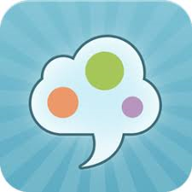 | Free | Secondary school age | Developed in collaboration with a research team from UWE, Bristol.  Offers a range of self-help methods for people trying to manage anxiety including relaxation exercises, anxiety tracker, psycho-education and online forum. | IOS & Android
App name | Cost & Privacy Info | Age range | Description | Compatible phones
Settle your glitter   | Free | All ages | Shake up the glitter; match your breathing to Puffy the puffer fish and pair deep breathing with calming visual. Allows you to select an emotion (mad, sad, silly or worried) and rate how strongly you are feeling that emotion. | IOS (iPhone) & Android
Calm Harm  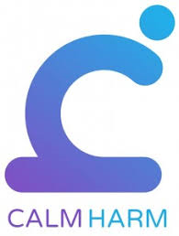 | Free  Password protected  Asks for some anonymous information for ‘research purposes’ (year born, country of residence, gender and whether receiving professional support currently) but this is voluntary. | Secondary school age | It provides tasks that help you resist or manage the urge to self harm. Various tasks available covering a range of topics including distraction, expression, release and breathing. The app also has a ‘Get Help’ section which provides phone numbers (Childline, Samaritans, 999) depending on the type of help selected. | IOS & Android
Wellmind   | Free | Secondary school age | NHS app designed to help with stress, anxiety and depression. Includes advice, tips and tools to improve mental health and boost wellbeing. Includes body map which shows how anxiety, stress and depression affect the body.  Has Snake distraction game. | IOS & Android
What’s Up – A Mental Health App  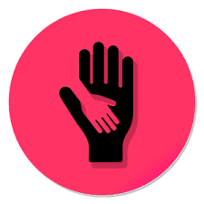 | Free –asks for voluntary donations and provides users with a theme for their app. | Secondary school age | Incorporating CBT & ACT methods to provide coping strategies for depression, anxiety, anger and stress.  Good section on 12 unhelpful thinking patterns, metaphors and 10 simple ways to manage worries (e.g. turn your worry into a movie). | IOS & Android
Breathe 2 Relax   | Free | Secondary school age | Teaches you diaphragmatic breathing as a relaxation technique. Guided deep breathing audio with visual, allows you to shorten or lengthen your exhale. Also includes demonstration video. | IOS & Android
App name | Cost & Privacy Info | Age range | Description | Compatible phones
Mood Tools – Depression Aid  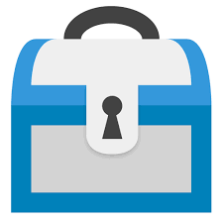 | Free but does ask for donation. | 14-18 – some of the material is more suitable for adults e.g. find a therapist link | Thought diary, activities, safety plan, information, PHQ9 and video – links to YouTube videos.  Videos – guided meditation, soothing sounds and TED talks.  List of activities and asks you to rate mood before and afterwards.  Has good section on making a safety plan that you can personalise.  Resources include link to ‘find a therapist’. Includes in-built PHQ9 which provides score and indication of severity of depression, which could potentially be unsuitable/ unhelpful. | IOS & Android
Fear Tools –Anxiety Aid  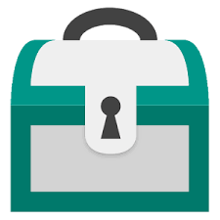 | Free to use | Secondary school age | Basic psycho-education about different types of anxiety (not very child friendly). Includes GAD7 which provides score and indication of severity of anxiety. It has a good fear hierarchy where you can set your own goals and rate the anxiety level. Simple diaphragmatic breathing visual.  Useful for symptoms related to GAD, phobias and panic disorder. | IOS & Android
Chill Panda   | Free  No personal information entered is collected, only anonymous analytics (session length and device model). | 6+ | The app incorporates measuring your heart rate (using your phone camera) and suggests tasks to suit your state of mind. Tasks include simple breathing techniques and light exercises to help with worry. Shows you how feeling good or stressed can affect your body. | IOS & Android – requires a mobile with a camera.
Suicide Safety Plan   | Free | Upper secondary school age | Encourages users to log warning signs, generate a list of family/ friends to support or distract during ideation, and create a list of ‘reasons to live’ and emergency contact numbers. | IOS & Android
App name | Cost & Privacy Info | Age range | Description | Compatible phones
In Hand   | Free | Secondary school age | Uses a traffic light system – asks the user to rate how they are feeling, and then provides prompts, quotes or tips that might be helpful. Suggestions and activities include listening to music, jotting down your feelings (in the app) and calling Samaritans.  It’s apparently made by young people for young people. No sign up needed, also works online and offline. | IOS & Android
NHS Mersey Care’s Self-Help   | Free | You must be at least 17 years old to download the app due to the nature of some of the self-help topics e.g. drugs & alcohol | Self-help guides written by Clinical Psychologists. They include the following topics: abuse, alcohol and you, anxiety, bereavement, anger, depression and low mood, domestic violence, eating disorders, food for thought, health anxiety, hearing voices, obsessions and compulsions, panic, PTSD, postnatal depression, DSH, shyness and social anxiety, sleep problems and stress.  The guides include video introductions, PDF guide and audio guide. | IOS & Android
Stop Breathe & Think  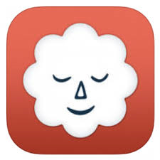 | Free to download which provides access to foundational meditations.  Requires monthly subscription of £9.99 for access to most features. | Secondary school age  Kids version available for younger children (below) | Meditation and mindfulness app. Over 55 mediations available.  Asks you to sign up, although does have ‘just browsing’ option. Whilst ‘just browsing’ it asks the user to rate how they’re feeling physically, mentally, emotionally (good list of emotions). Based on ratings suggests suitable meditations. There are quite a few foundational meditations which are free. | IOS  Premium content only available on IOS.  Web version of app is available and could be used on Android phones.
Thought Buddy  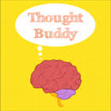 | Free  Currently the app needs updating to be compatible with most recent IOS update. | Secondary school age. | User chooses a smiling or frowning face and rates the intensity of this emotion. A graph charts mood and fluctuations over time.  Has mood diary and thought tracker. Aims to help you monitor and challenge thoughts creating more helpful thinking styles. | IOS only
App name | Cost & Privacy Info | Age range | Description | Compatible phones
Stop Breathe & Think Kids  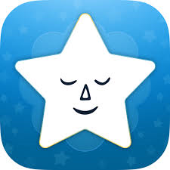 | Free to download and 15 free mindful activities for every situation.  £9.99 monthly subscription provides access to 25 premium missions for more meditation and mindful activities. | Children aged 5-10 years  Asks parents/ guardians to share email to confirm they consent to their child using the app. Also asks you to create a password.  Parents/ guardians can create up to 5 child profiles. | Kids can check into how they are feeling using fun emojis and try recommended mindful missions and meditations tuned to those emotions. Stickers reward their progress and keep the mindful activities engaging.  All of the missions and meditations involve colourful videos. | IOS  Web version of app is available and could be used on Android phones.
SAMH – Scotland’s MH   | Free | 15+  All of the information is relatively mature in content and the case study videos are all of adults | Initially has an option to choose whether you would like help for yourself or a friend or family member. Provides a range of information about getting help for mental health problems. Includes signposting to self-help online resources (e.g. MoodGYM & Moodjuice), sources of support, how to access counselling/ therapy and emergency telephone numbers. Also includes a couple of case study videos. | IOS & Android
Thought Diary   | £2.99 | 15+ | Designed by a CBT therapist and Clinical Psychologist. There is a feature which allows the thought diary to be emailed straight to the therapist, when emailed it takes the traditional format of CBT thought diary. | IOS & Android
Cove  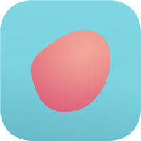 | Free | Secondary school age | A type of musical journal created for young people.  Create music to capture your mood and express how you feel. Allows you to adjust different elements of the music to fit how you feel using base chords, melody and percussion. You can then store your music in a personal journal, or send them to someone and let the music do the talking. | Part of the NHS app library.
App name | Cost & Privacy Info | Age range | Description | Compatible phones
Safe Spot   | Free | Two internal versions – one for adults and one for children | Developed by 2 CAMHS Psychiatrists. Asks at the beginning whether you are an adult or child, then you create an avatar. Audios include muscle relaxation, breathing, mindfulness and guided imagery. Contains comprehensive directory of useful contacts. | IOS & Android
Relax Lite  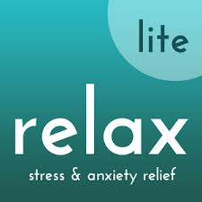 | Free (for light version)  £2.99 for complete version. | Secondary school age | The light version includes guided deep breathing exercises and 8 minute meditation audio. Simple visual and audio to guide you through the breathing. | IOS & Android
Other apps
Brain in Hand  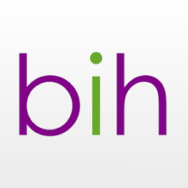 | Free to download but expensive to run. It costs £45 to £99 a month depending on the tariff you choose. Costs can be covered by a range of schemes incl. Access to Work, Disabled Students Allowance, schools etc. | 16+ | Originally developed as an app for people with ASD, now expanded to also help people experiencing mental health difficulties and those with acquired brain injuries. Allows you to create a diary of activities, personal coping strategies and traffic light system to monitor anxiety and contact National Autistic Society if needed. | IOS & Android

Privacy and Data Protection
The privacy policies for each app are very lengthy and therefore hard to summarise. It is worth encouraging young people and their parents/ guardians to check how their personal data will be used if they have any concerns. As a general rule though, often ‘active apps’ or diary apps, which encourage the user to input their data and personal information are the more likely apps to store data. This can apparently only be done when consent has been given though.

